ERFWeb Administrator Guide
Nov 5, 2026 · @Jay Bryan
The System Administrator sets up accounts, roles, approvers, rates and rules, so every report routes to the right people at the right rates.

Before you start
Sign in as admin in Chrome or Edge. The left menu shows Users, Master data and Rules under Administration, Scope and Rates under Signatory structure, and Audit.
- You set up the system; you never see report contents and never file or approve.
- You cannot change your own account: no edits, role changes, resets or deactivation on it (it shows This is you).
- Every change you make is written to the audit trail, which Finance can read too.
Set things up in this order the first time: master data, then accounts and roles, then scope, then rates, then rules.

Set up a new person

Create the account
- Click Users, then New user.
- Under Profile, fill Full name, Position, Department, Job grade, Email (name plus Domain) and Mobile no. (needed for SMS).
- Optional: under CRM link, search the CRM by name, initials or employee ID and pick the person. Empty Full name and Mobile no. fill from the CRM.
- Turn on Available as a “Work With” person on expense lines if others list this person as a companion.
- Under Sign-in, set Username and a Temporary password (at least 8 characters) twice. The person must choose their own password at first sign-in.
- Save.
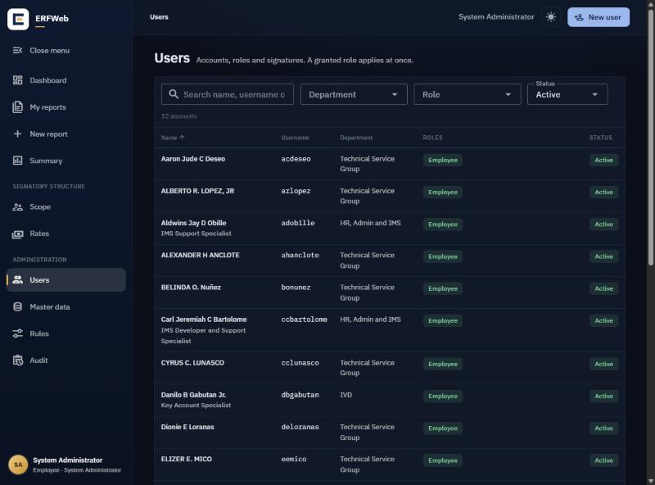

Grant roles
Everyone is an Employee. On the person's page, under Roles, click Grant role, pick the Role, add a Note (optional) and click Grant. It applies at once.
Role | Gives
Signatory Level 1 / Level 2 | Approvals, Delegations, Budgets; needs a scope (next section)
Finance | Finance queue, Signatures, Budgets, Audit
Expense Verifier | Verifications
A System Administrator holds no other role; Finance cannot also be a signatory or a verifier. Revoke removes a role.

Load the signature
Under Signature, click Upload signature (Replace signature when one is on file), choose a PNG or JPEG and click Save signature. The card shows Waiting for Finance until Finance approves the image on their Signatures page, then Approved. Only an approved signature prints on the R47, with an ELECTRONIC SIGNATURE watermark: for the employee, and for signatories once they approve. A signature is optional: without one the person can still file and signs the printed R47 instead.
Remove signature deletes it after you confirm with Remove. Every R47 that person prepared or approved, past ones included, then prints their name without a signature until a new one is loaded and approved.

Scope: who approves for whom
A scope assignment names the signatory for a department or for named people, at Level 1 or Level 2. Each employee needs exactly one Level 1, and one Level 2 when Level 2 is required.
- Click Scope, then New assignment.
- Pick the Signatory (they must hold that level's role) and the Level.
- Under Covers, choose a whole department, named people, or a department except named people. A named person beats the department rule.
- Optional: an Approval limit (blank for no limit) and Effective from / Effective to (blank for open-ended).
- Save. A save that would give anyone two signatories at one level is refused.
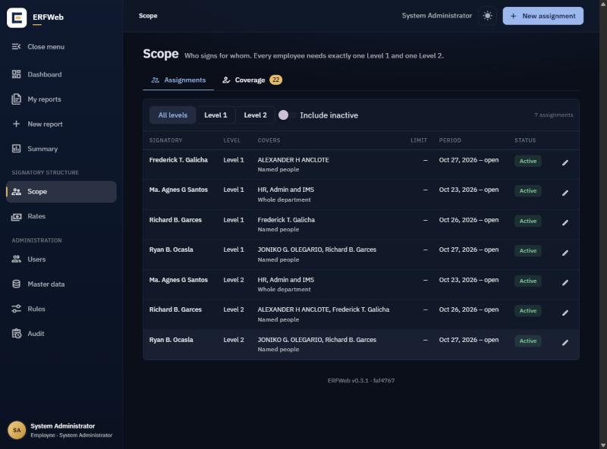
Click a row to edit any field, including the signatory and level. Reports already filed keep the signatories they were routed to.
Check coverage. The Coverage tab lists every active employee with their Level 1 and Level 2. Turn on Only problems to see who has none or too many; fix those before go-live, because they cannot file.

Rates
A rate profile holds the allowed amounts per category (meals per meal: Breakfast, Lunch, Dinner, OT Meal). A report always uses the rate in force on the expense date.
- Click Rates, then New profile; give it a Name and click Create.
- Under Rate lines, click Add line: pick the Category (and Meal), the Amount, Rate type, Requires receipt, an optional Frequency cap, and Effective from.
- Under Assignments, click Assign profile and choose a person, a job grade, a department or the whole company, with Effective from. A person's own assignment beats their grade, which beats their department, which beats the company.
- Use Check who gets what to see the rates a person gets on a date.
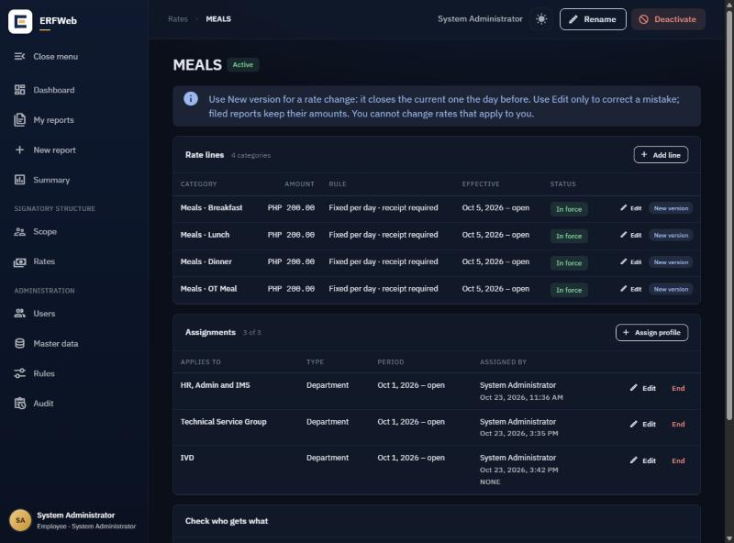
Changing a rate. Click New version on the line (it closes the old one the day before), or Edit to correct a version in place with a reason. A change dated before today needs Backdate override and a reason. Filed reports keep their amounts.
You cannot assign a profile to yourself by name.

Master data
Master data has a tab per list. Entries are deactivated, never deleted.
Tab | What to keep up to date
Departments | Names, and the department's Reviewed by (R47) initials (blank uses the Rules default)
Cost centers | One per department, with this year's budget; Earlier budgets shows past years read-only. Budgets are for monitoring only
Currencies | The Default currency for new reports
Fare modes | Taxi, Grab, Angkas… with Sort order; Others lets the employee type the mode
Sites | Locations used on reports
Expense categories | Read-only: fixed by the R47 layout
Set a new budget on each cost center at the start of every year.

Rules
Rules holds the workflow settings. Change what you need and click Save rules (or Discard changes).
Section | Settings
Approval routing | Always require Level 2 approval, Level 2 threshold amount
Service levels and escalation | SLA days, Level 1, SLA days, Level 2, Escalate after
Filing rules | Filing cut-off (how old an expense may be), Receipt required above, New-account cooling period
Expense report (R47) | Reviewed by (default initials), Signatures on the R47, Format of the R47 and Open the R47 designer (see below)
Notifications | Email and SMS switches, Notification from address
Account email domains | The domains offered on the user form; the first is the default
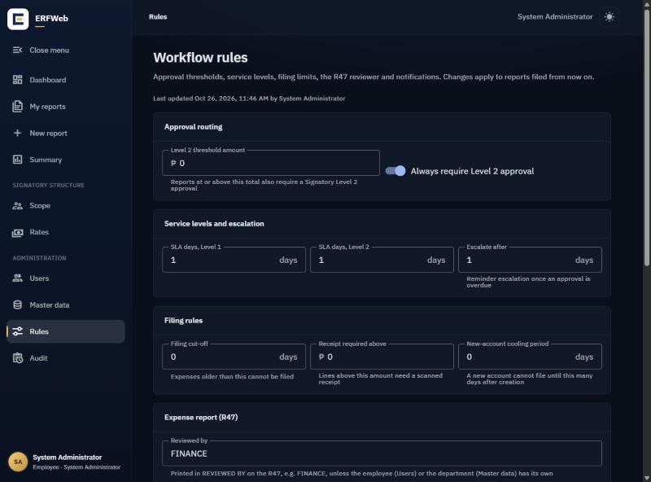

Signatures on the R47
Under Expense report (R47), pick how signatures print:
- E-signature (default): signatures Finance approved print with an ELECTRONIC SIGNATURE watermark and "Electronically signed in ERFWeb" with the date, time and ERF reference.
- Status only: no signature images; each place prints "Electronically approved" (or "Electronically filed" for the employee) with the date and time.

Format of the R47
- Under Format of the R47, pick the PDF engine: QuestPDF (the original R47 renderer) or PDFsharp (the same form drawn with PDFsharp). Both print the same form and page breaks.
- Edit the header details: Company name, Company short name (also printed on the BAL DUE TO line), Form title, Document code, Effectivity date (printed as typed, e.g. May 15, 2023) and Revision no. Each has a character limit so it fits its box.
- Click Save rules. The next R47 printed or emailed uses the change; nothing needs restarting.

R47 designer
Click Open the R47 designer to change the layout of the form: margins, band heights, column widths, type sizes, colours and fixed texts. The order and content of the bands stay the controlled form.
- In the drawing, drag a band edge or column divider, or select one with Tab and move it with the arrow keys (Shift moves 5 pt). Click a band to open its values.
- For exact values, open a section on the right: Page margins, Header, DATE stamp and employee, Grid (the 13 column widths, which must fill the width between the margins), Totals rows (Revolving fund line), Cash advance and reconciliation (Note after BAL DUE TO), Footer (the promise, up to 6 lines of 70 characters, and Promise alignment Left or Center) and Type and colours (two colours; the grid stays in Tahoma).
- Under Preview, pick Sample report (made-up data, two pages) or A report (search by employee name, purpose or ER reference; drafts included), pick Rules page engine, QuestPDF or PDFsharp, and click Preview PDF. A preview saves and sends nothing.
- Click Save layout and confirm with Save layout. Every R47 printed or emailed from then on uses it; R47s already printed keep their old copies.
Undo (or Ctrl+Z) steps back, Discard changes returns to the saved layout, and Reset to standard returns to the standard form. The chip at the top reads Saved layout or Standard form, plus Unsaved changes while you edit. When a value does not fit, a list under Fix these before saving or previewing says what to change.

SLA reminders
SLA reminders card. It shows whether the server sends reminders (Reminders:Enabled), the run time and Next run, which Channels (email, SMS) are set up, and the Last run with its result. No run recorded yet means it has not run since the last deployment. The on/off switch and run time are in the server's settings file, not on this page.
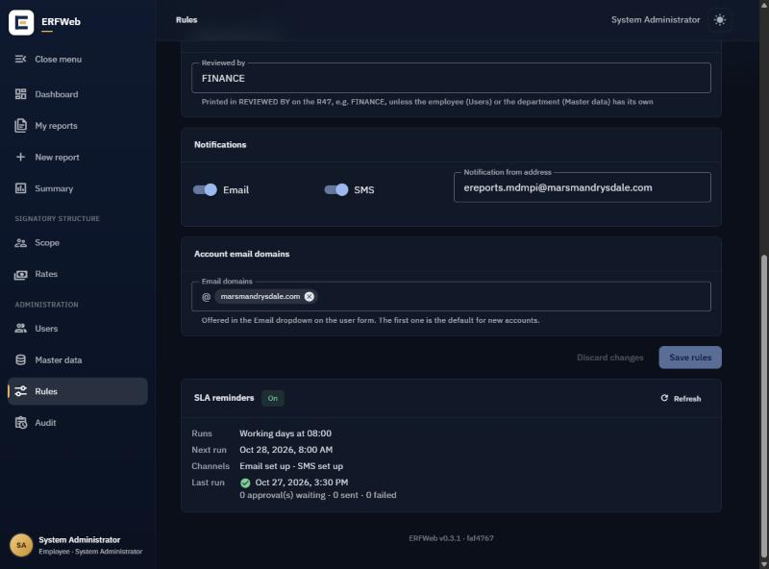

Everyday tasks
- Forgotten password or locked out. Open the person in Users, click Reset password, enter a New password twice and click Set password. This also unlocks the account; they choose their own password at next sign-in. (Five wrong passwords lock an account for 15 minutes.)
- Someone leaves. Click Deactivate on their page. They can no longer sign in; their reports and history stay. End their scope assignments too.
- Change details. Click Edit on their page. Changing department or grade can change their rates and approvers from that day.
- Read the audit trail. Audit lists every administration and workflow change with who, when and what; filter by event, person and dates. It cannot be edited.
Test system only: Delete buttons. When ERFWeb runs in test mode, a red TEST chip shows at the top and a red Delete (bin) button appears on records such as users, master data, rate profiles, scope assignments, delegations, budgets, reports and audit entries. It asks Delete test data? and deletes permanently. The live system does not run in test mode, so these buttons never appear there.

Common problems
What an employee or you sees | What to do
Checklist says no approver found, or two | Fix their scope; check Scope → Coverage → Only problems
A signature does not print on the R47 | On their user page the Signature card must show Approved; if it shows Waiting for Finance, ask Finance to approve it on Signatures. With Status only under Rules, no images print
Meal amount stays ₱0 | No rate profile reaches them on that date; check Check who gets what
New employee cannot file yet | The cooling period has not passed; lower it under Rules if needed
No texts or emails arrive | Check their mobile number and email, and the Notifications switches
Role grant refused | The combination is not allowed (for example Finance plus signatory)
CRM search says unavailable | The CRM is down or not configured; save without the link and add it later

